# GenAI

Learn by doing –

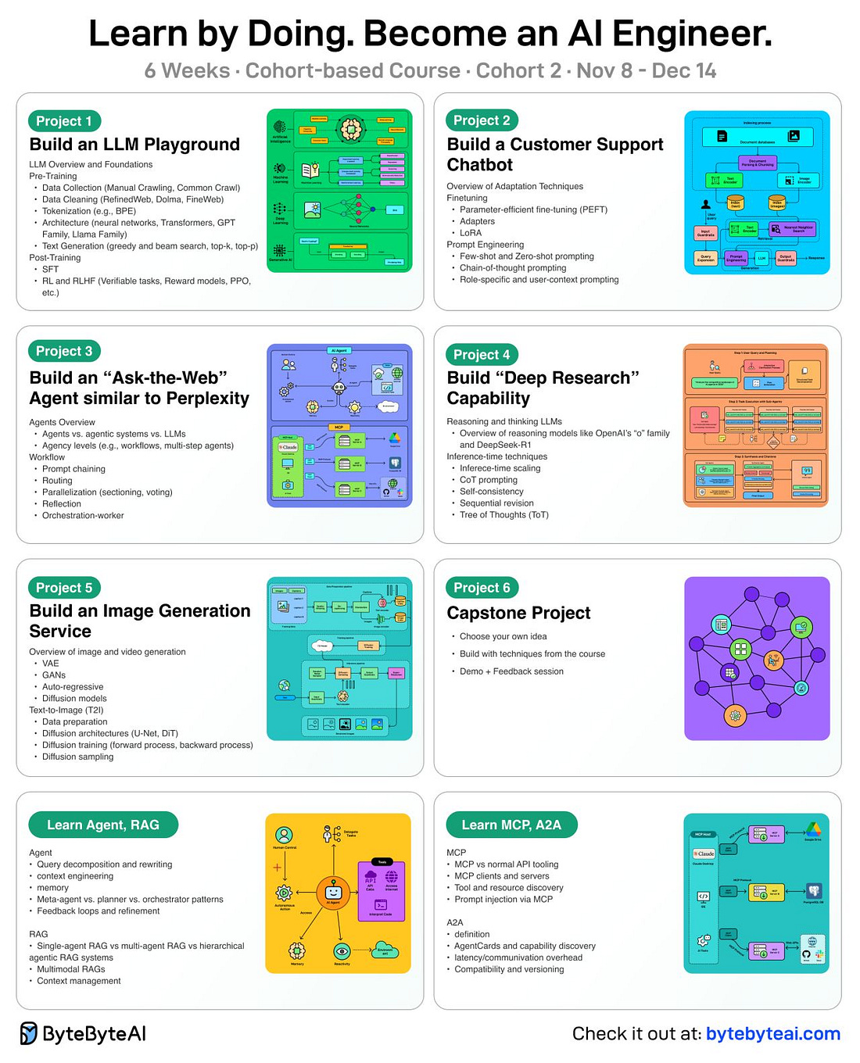

Servers you should know in modern systems –

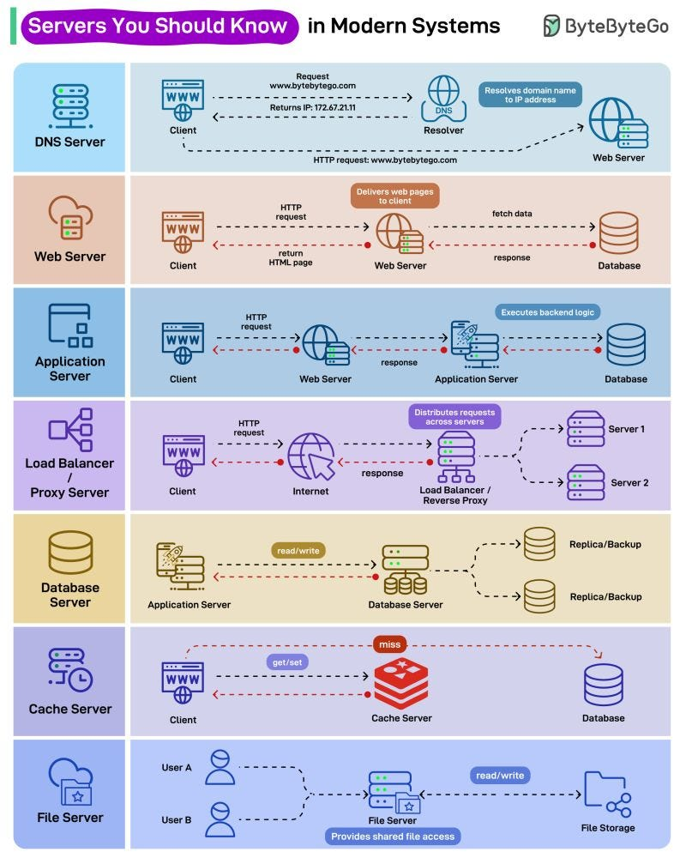

Building blocks of modern networking –

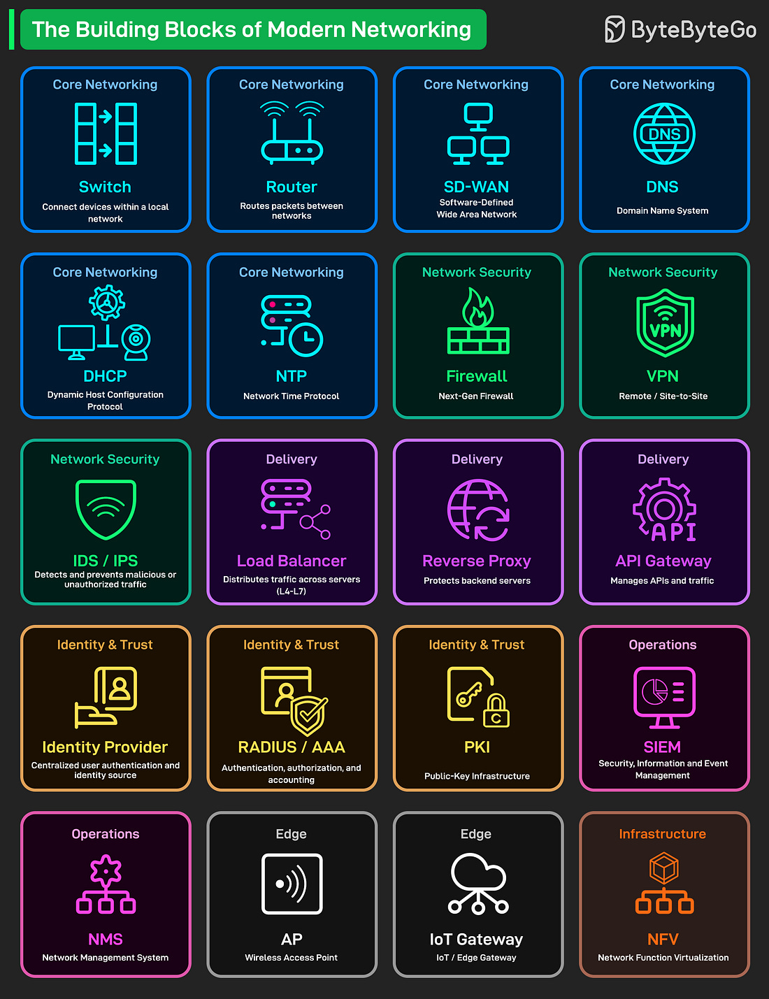

Network services that power modern connectivity –

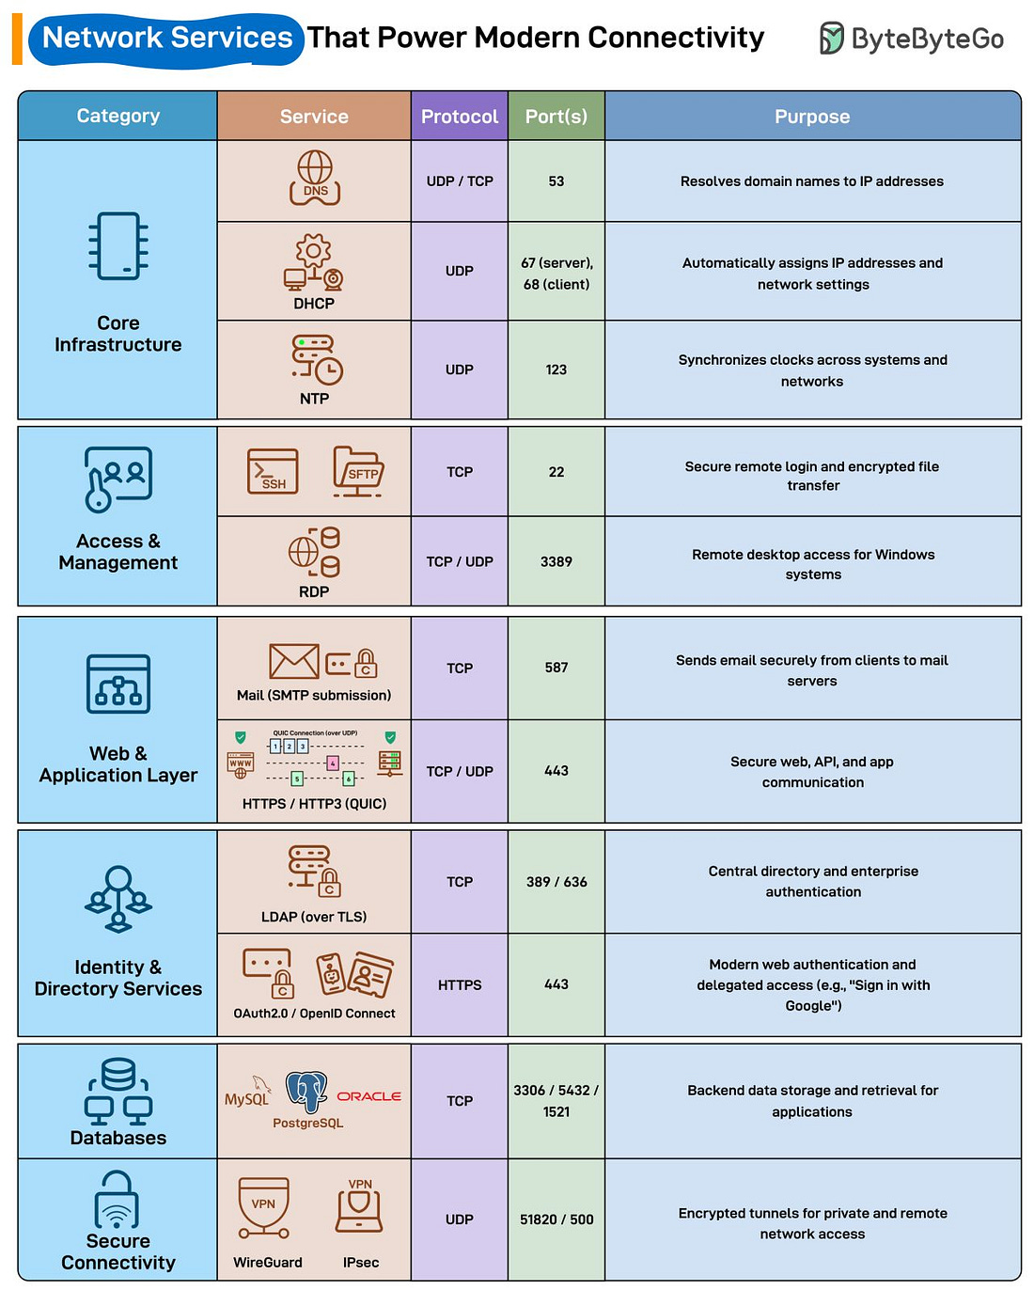

# Choosing Generative AI Tools and Technologies

Cost – token-based APIs (cheap for pilots, expensive at scale), in-house models (high upfront, lower long-term costs).

Text based AI - If we need cutting-edge reasoning, choose OpenAI, for regulatory or long-document safety choose Claude, for scale and google ecosystem leverage, Gemini, and for developer productivity today choose Copilot.

Image generation base AI - OpenAI Dall.E for clarity and control (can regenerate specific part of the image), Microsoft for safety and enterprise compliance, Midjourney for creativity and beauty, Gemini for scale and brand consistency, and Sora / Veo for the future generative video.

GenAI in audio and speech – best interface is not interface; voice is fast becoming the most human way to talk to machines. Use Whisper or Azure for accurate call center or meeting transcription; choose Google if you need global, multilingual coverage; pick MS for compliance and custom branding voices.

Unlike traditional chatbots that respond to single prompts, AI agents can plan, reason and execute multi-step tasks, adapting their actions based on context and feedback. In essence, they more AI from simple answering questions to getting things done like OpenAI with AgentKit and GPT builder, MS copilot studio, LangChain, Amazon Bedrock, n8n. It is a shift from assistive AI to autonomous AI.

# Prompt Engineering Best Practices

Vague prompts confuse the model, biased prompts mislead it, and overloaded prompts can’t go deep on any of them.

Hallucination is when the model produces information that looks confident but isn’t actually true.

Instead of asking everything into one model, extract it into different chunks –

Instead of saying thank you or please, do a thumbs-up to avoid resources which AI uses behind the scene like electricity, water, machine running –

Best practice – tell it first to adopt a specific person or step into a professional role.

Reusable prompt formula –

We can generate the detailed prompt from ChatGPT for generating a image –

Hallucinations happens because LLMs can be overly agreeable, trying to give you answer even they are not certain. Sychophancy – when the model agrees with you even if you are wrong, just to sound helpful which is a classic “people-pleaser” behavior.

Temperature in API

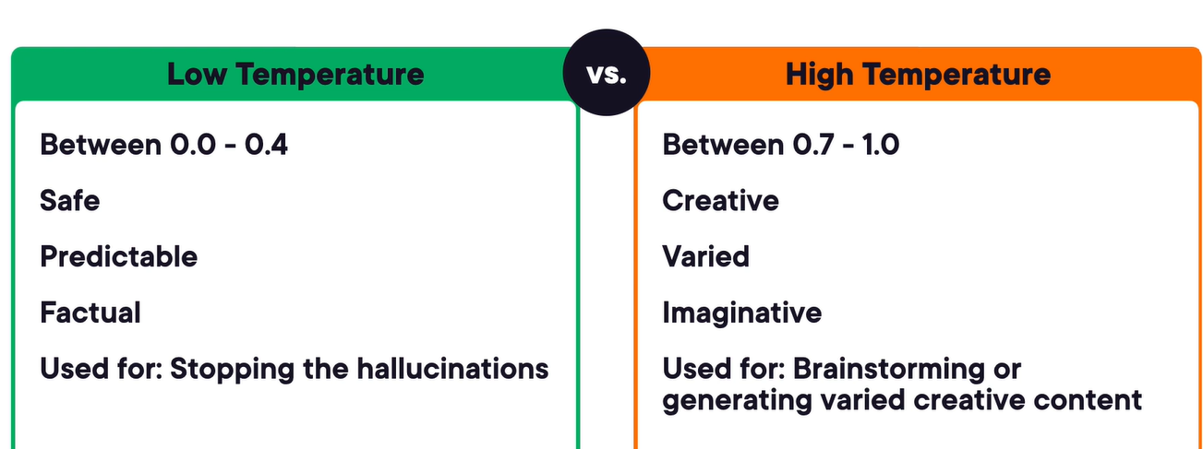

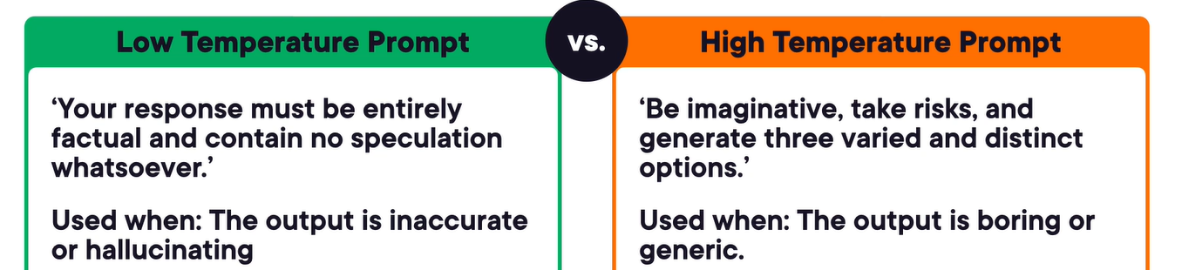

Meta-prompting – it is the act of guiding the LLM to govern or evaluate its own thought process or response structure.

Self-reflection prompts –

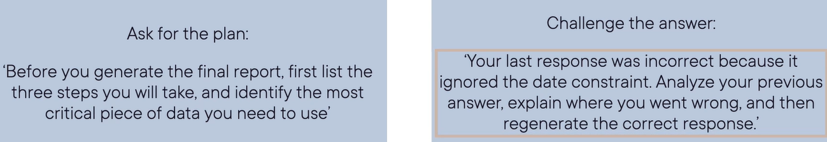

Parameters for image generations – aspect ration, reproducibility and artistic intensity.

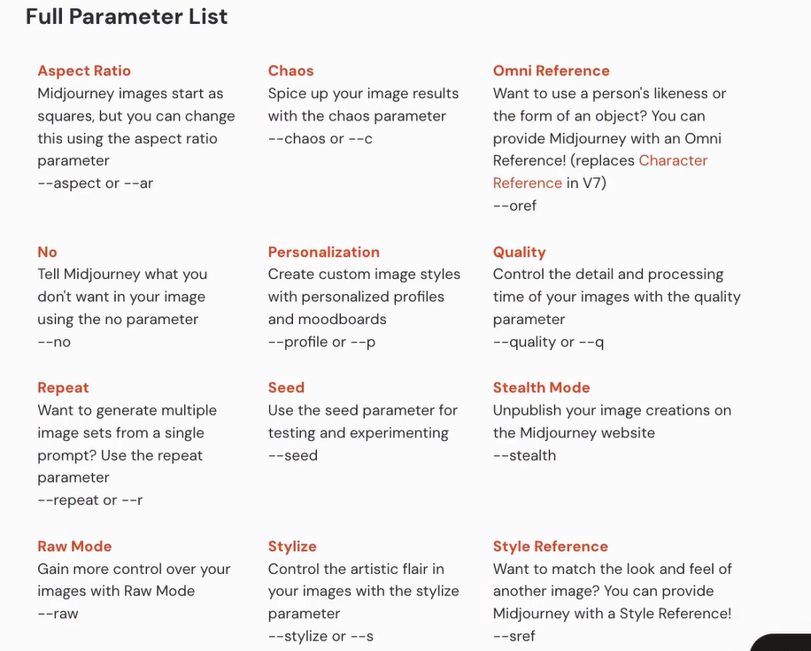

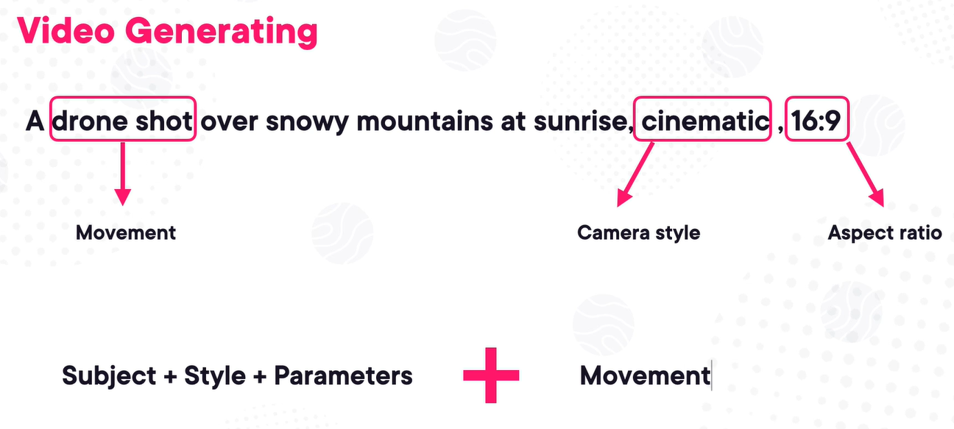

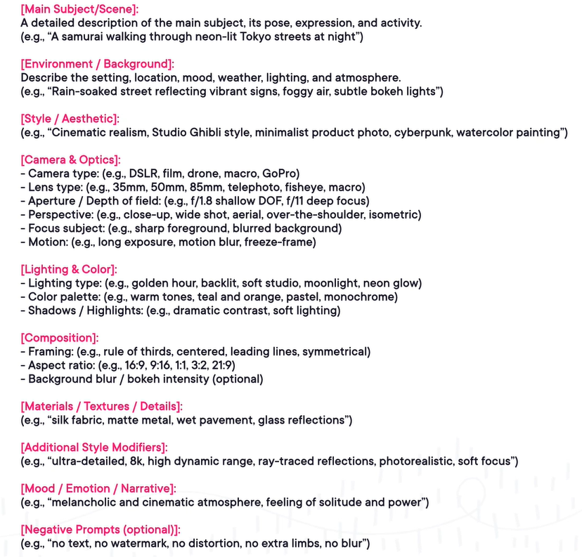

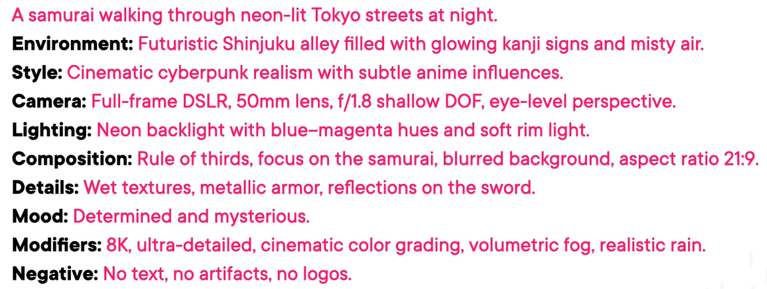

We can use this website for reference which will show the prompt which gets to used to generate specific image - <https://lexica.art/>

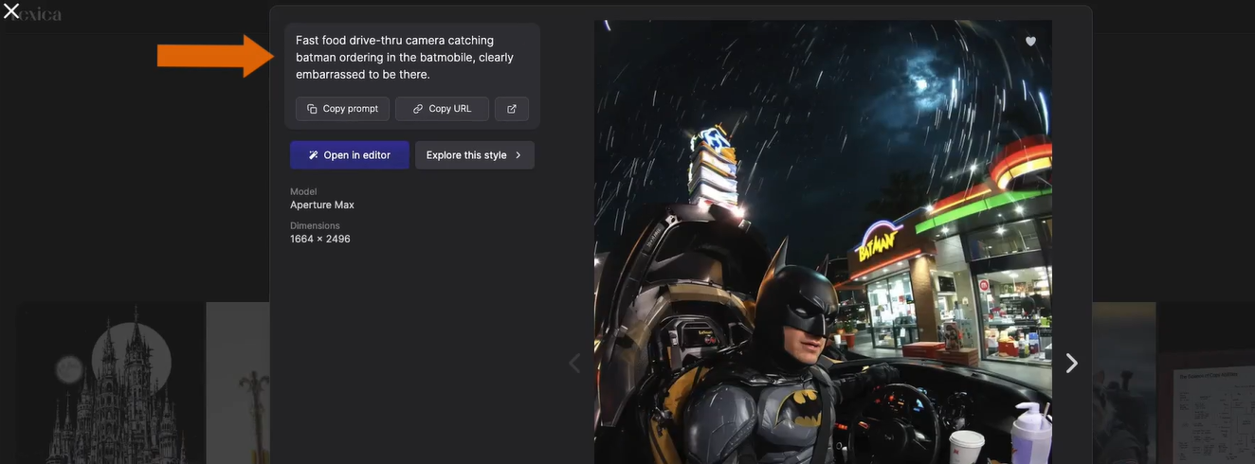

ReAct prompting – it is advance prompting technique. Benefits – measurable output, reduced hallucination, dynamic context management –

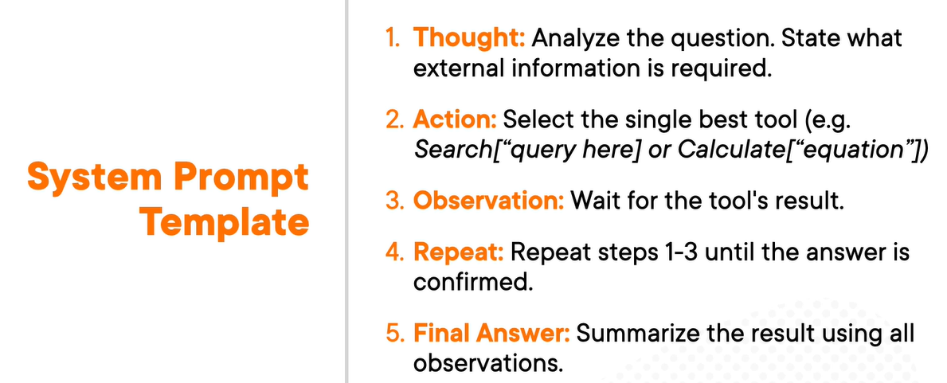

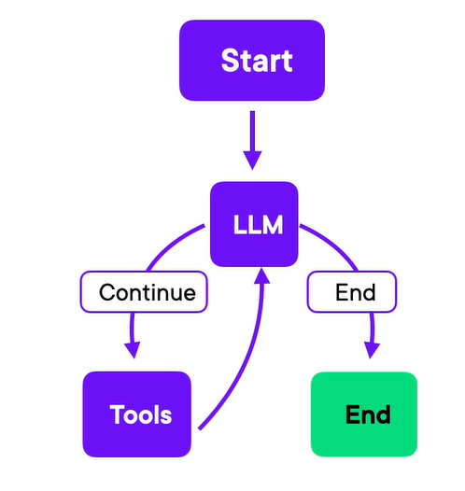

Prompt injection – when a malicious user tries to use clever prompt to trick the AI agent into violating its core rules.

The data firewall with guardrail –

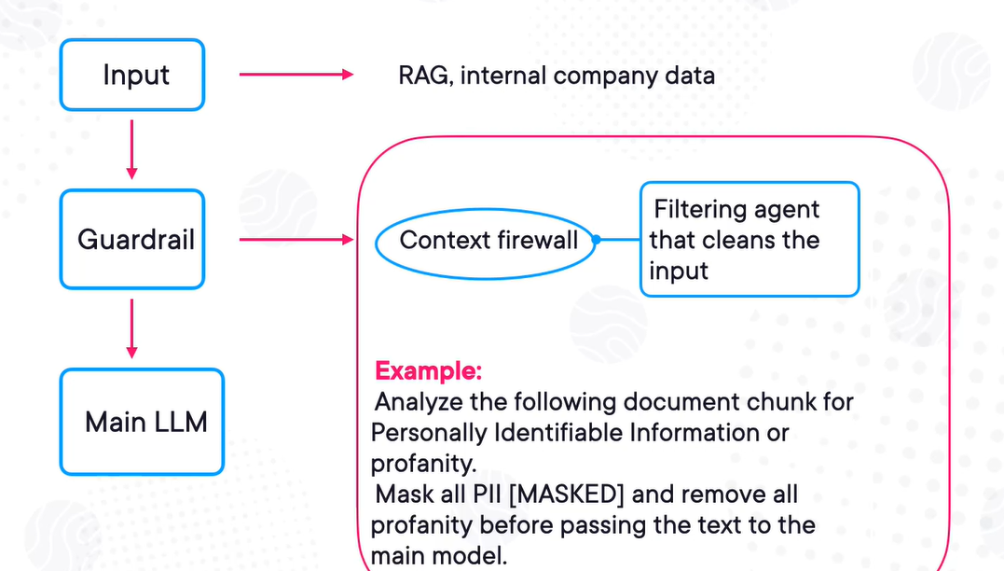

Avoiding biases –

